PROG32356 .Net Technologies using C#

Midterm Exam

Posted: Feb 23 2021

Due: March 02 2021 at 11:59PM

In class, we have worked together to use ArrayList of Objects, Mouse Event Handler, Canvas, and GUI element to build the basic Shape Animator game.
In this midterm exam, you are asked to demonstrate your understanding and mastery of these concepts and techniques by extending the game to incorporate the following features:
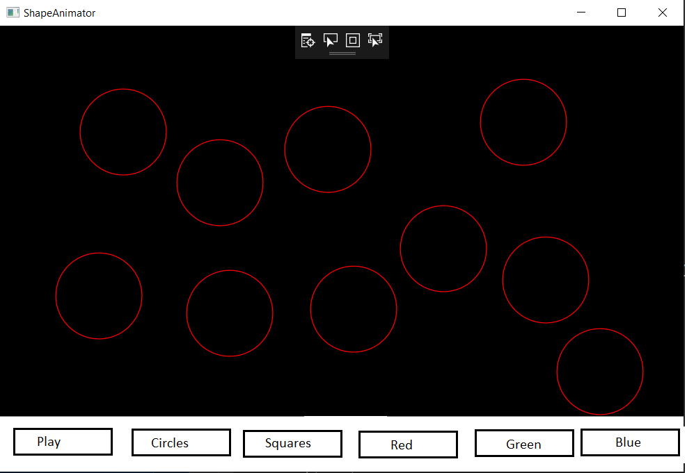

Feature 1: The Play button [3 points]
Currently, the Play button makes the circles moves horizontally and bounce off the right wall, but still fall off the other 3 side.
Your task: Make the circle travel diagonally and bounce off all the 4 walls and not fall off.

Feature 2: User can control the size of the circles [5 points]
Currently, the user cannot control the exact size of the circles when he/she draw them.
Your task: To modify the game so that you user draw circles with 2 clicks: The first click specifies where the center is, and the second click specify the point through which the circle goes through (i.e. the rim of the circle)

Feature 3: User can control the color of the circles [4 points]
Currently, all circles are drawn in red.
Your task: To allow the user to choose the color by clicking on the Red, Green, Blue button before drawing.
If the user clicks on the red button, all the circles he/she draw subsequently will be in red (until the user click on a different color button to switch color). The default color (without clicking on any button) should be red. For example: First, the user selects red color and draw 10 circles, all these will be red. Then he/she clicks on blue button, and add 3 more circles onto the canvas, these will be blue, so we end up with 10 reds and 3 blues.
Color choices can happen anytime, before the play button was click, or after the play button was click.

Feature 4: User can draw squares in addition to circles [5 points]
Currently, the user can only draw circles.
Your task: To allow the user to draw squares as well.
All the squares should behave in a similar fashion as the circles:
- They can be added before or after the Play button has been clicked.
- They travel diagonally and bounce off the 4 walls.
- Their sizes can be controlled by the user: The user draws a square with 2 clicks: The first click specifies the top-left corner, and the second click specify the bottom-right corner.
- There colors are controlled in the same way as the circles.

Feature 5: Black Hole introduction [3 points]
Currently, the Shape Animator world is a very peaceful world. The circles and squares travel around without any worry of danger.
Your task: To introduce an invisible black hole at location (300,300). If a shape (circle or square) touch this invisible black hole, it will be destroyed (disappear from the screen forever).

Marking Rules I will follow:
- If your submitted program does not compile (i.e. gives error(s) when I try to compile and run it): You receive a zero. You MUST ensure your program compile and run cleanly. If a feature is not finished, comment it out and ensure your program compiles and runs before submitting. It is OK if your program contains bugs -- I will just deduct marks depending on the bugs. But it must compile and launch.
- If your code closely resembles someone else’s code, or to some code posted online, I will ask you to get on a video interview and ask you to reproduce the functionalities on your own, and if you are not able to, I will proceed through the Academic Integrity process.

